Contents
1 Project 3
1.1 Project 3
1.2 Description 3
1.3 Revision History 3
2 Overview 4
2.1 Purpose 4
2.2 Scope 4
2.3 Requirements 4
2.3.1 Traceability Matrix 4
3 System Architecture 5
3.1 Hardware Requirements: 5
3.2 Software Requirements: 5
4 Data Design 6
4.1 Persistent Data 6
4.1.1 Dataset 7
4.1.2 Static Data 8
4.1.3 Persisted data 10
4.2 External Interface Data 11
4.2.1 RabitMQ : 11
4.3 Transformation of Data 11
4.3.1 ApplicationUpdate : 11
5 Software Domain Design 12
5.1 Software Application Domain Chart 12
5.2 Software Application Domain 13
5.2.1 Sub Component 13
5.2.2 Class Diagram 14
5.2.3 Use Cases 15
5.2.4 Deployment Diagram 25
6 Other Interfaces 25
7 Outstanding Issues 25
8 Non Functional Requirement 25
9 References 26
10 Glossary 26

Project

Project

The Mastercard Payment Gateway offers the APIs to manage merchants onboarding and their transactions. Merchant Boarding allows to automatically board merchants onto Mastercard Payment Gateway.

Description
- MPGS Supports end-to-end integration of the information flow from a sales opportunity through to merchant sign-up to use gateway services, to boarding a merchant to use Mastercard Payment Gateway, to integration of common data with billing systems.
- Drives scalability and efficiency of operational processes through automation and decreased labor costs.
- Supports increased customer satisfaction by providing a means for streamline customer service.

Revision History
Date | Comment | Author
21 Mar 2023 | Initial Draft | Sudesh Mane

Overview

Purpose

The purpose of the document is to provide support to onboard the merchant details onto Mastercard Payment Gateway. Set up new/existing merchants by entering details about each merchant, including the functions they are allowed to use in Merchant Administration. This can include, for example, the cards that they are authorized to use, and the currency that they operate in. Changes to merchant profiles need to be approved before they come into effect.

IP whitelisting is required to perform the MPGS API operation.

Scope
Adapter – Adapter invoke MPGS API with the help of Basic authentication.

MPGS - provides JSON based rest API connectivity to the client to setup merchant details, Address details, Acquirer details etc...

Requirements
Break down the requirements to provide a ballpark estimate.

Traceability Matrix
Cross reference this document with your requirements document and link where satisfies each requirement.
SRS Requirement | SDD Module
Req 1 | [NASSC-2789] MPGS Analysis - Jira (atlassian.net)

System Architecture
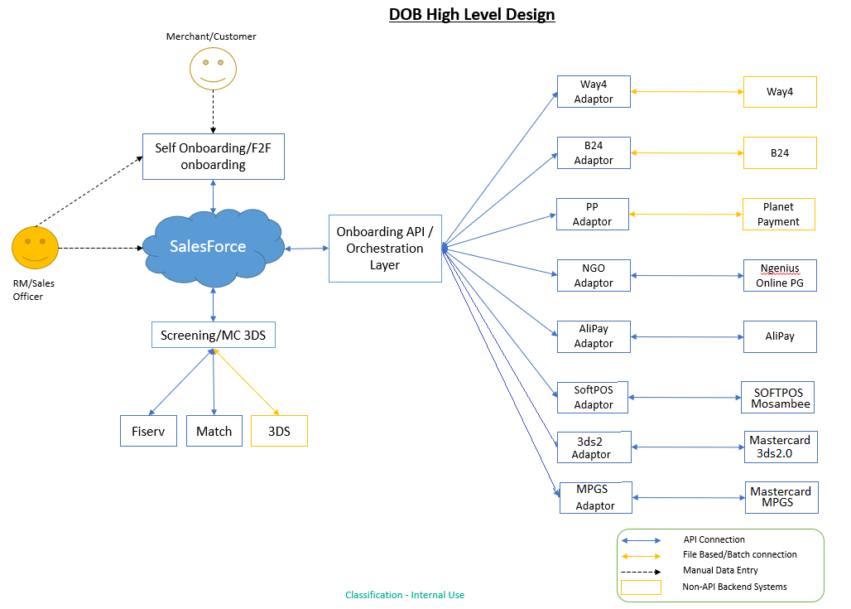

Hardware Requirements:
Standard Server config | ELK Server (if no shared service available)
RHEL 7 (or latest available) | RHEL 7 (or latest available)
8 core cpu | 8 core cpu
80GB storage | 1000GB storage
32GB memory | 32GB memory

Software Requirements:
Component | Infrastructure | Licensing
Java 8 | 2 RHEL Linux server | Commercial license, Included with server provisioning
RabbitMQ Cluster | same servers | We use free open-source version, commercial version is available with a subscription fee for support.
Selenium | same servers | Free
Ansible | 1 server | Free, commercial support available
ELK | 3 servers | Free, commercial subscription available
MongoDB | 2 servers | Free, commercial support available

Data Design
Describe the data contained in databases and other shared structures between domains or within the scope of the overall project architecture.

Persistent Data
Describe/illustrate the logical data model or entity relationship diagrams for the persistent data.

- apiOperation
- merchant
- acquirerLink
- acqLinkRegion_
- accountUpdaterEnabled
- acquirerId
- allowableTransactionFrequency
- allowableTransactionSource
- authentication
  - masterCardSecureCode
    - mastercard_3ds1Auth
- authentication
  - verifiedByVisa
    - visa_3ds1Auth
- bankMerchantId
- cardType
- currency
- defaultTransactionFrequency
- defaultTransactionSource
- enforceCscOnTransactionSource
- paymentType
- status
- terminalId
- address
- city
- countryCode
- postcode
- stateProvince
- street1
- cardMaskingFormat
- categoryCode
- contactName
- defaultOrderCertainty
- email
- goodsDescription
- webSite
- locale
- timeZone
- name
- partnerManagedRiskAssessment
  - transactionRiskAssessment
- configuration
- phone
- privilege
- risk
- privilege
- service
- state
- systemCapturedCardMaskingFormat
- timeZone
- transactionFiltering
- dynamic3DSecure
  - ipCountry
- rejectAnonymousProxy
- rejectUnknownCountry

Dataset
Describe persisted object/dataset and its relationships to other entities/datasets.
- MPGS Config
{
Acquirer: NI
merchantType: ECOM
acquirerLinkId: NETWORK2_S2I01
acquirerId: NETWORK2_S2I
msoId: NETWORK/merchant
API_BASICAUTH_NAME_JASYPT_ENC: ***************
CERT_ID_JASYPT_ENC: ***************************
ADMINPWD_JASYPT_ENC: *************************
}
{
Acquirer: NI
merchantType: POS
acquirerLinkId: NETWORK_LLC_S2I01
acquirerId: NETWORK_LLC_S2I
msoId: NETWORK_CP/merchant
API_BASICAUTH_NAME_JASYPT_ENC: ****************
CERT_ID_JASYPT_ENC: ****************************
ADMINPWD_JASYPT_ENC: *************************
}

Static Data
NI:
POS:
url: "https://test-gateway.mastercard.com/api/rest/version/69/mso/"
apiCrUpdOperation: "CREATE_OR_UPDATE MERCHANT"
accountUpdaterEnabled: false
merchantLocale: en_US
merchantTimeZone: Asia/Dubai
allowableTransactionFrequency:
- SINGLE_TRANSACTION
allowableTransactionSource:
- CARD_PRESENT
cardType:
- MASTERCARD
- VISA
currency:
- AED
defaultTransactionFrequency: SINGLE_TRANSACTION
defaultTransactionSource: CARD_PRESENT
paymentType: CREDIT #CARD PAYMENT
status: TEST_AND_PRODUCTION
defaultOrderCertainty: FINAL
privilege:
- AUTHORIZATIONS
- AUTO_AUTH_REVERSAL_ON_EXPIRY
- CAPTURES
- CHANGE_MERCHANT_TRANSACTION_SOURCE
- CHANGE_TRANSACTION_FREQUENCY
- ORDER_DOWNLOAD
- PURCHASES
- REFUNDS
- VOIDS
- ENFORCE_UNIQUE_ORDER_REFERENCE
- ENFORCE_UNIQUE_MERCHANT_TRANSACTION_REFERENCE
service:
- ENABLE_WEB_SERVICES_API
state: ENABLED
cardMaskingFormat: DISPLAY_6_4
systemCapturedCardMaskingFormat: DISPLAY_6_4
transactionRiskAssessment: STANDARD
transactionFilterDynamic3DSecure: false
ipRejectAnonymousProxy: false
ipRejectUnknownCountry: false

msoId: "NETWORK_CP/merchant"
userName: *****************************
userPass: ******************************
acquirerLinkId: NETWORK_LLC_S2I01
acquirerId: NETWORK_LLC_S2I
certificateSetId: *******************
administrativePassword: ******************

NI:
ECOM:
url: "https://test-gateway.mastercard.com/api/rest/version/69/mso/"
apiCrUpdOperation: "CREATE_OR_UPDATE_MERCHANT"
accountUpdaterEnabled: false
merchantLocale: en_US
merchantTimeZone: Asia/Dubai
allowableTransactionFrequency:
- SINGLE_TRANSACTION
allowableTransactionSource:
- INTERNET
cardType:
- MASTERCARD
- VISA
currency:
- AED
defaultTransactionFrequency: SINGLE_TRANSACTION
defaultTransactionSource: INTERNET
enforceCscOnTransactionSource:
- INTERNET
paymentType: CREDIT
status: TEST_AND_PRODUCTION
defaultOrderCertainty: FINAL
privilege:
- AUTHORIZATIONS
- AUTO_AUTH_REVERSAL_ON_EXPIRY
- CAPTURES
- CHANGE_MERCHANT_TRANSACTION_SOURCE
- CHANGE_TRANSACTION_FREQUENCY
- ORDER_DOWNLOAD
- PURCHASES
- REFUNDS
- SECURECODE_2
- TXN_DOWNLOAD
- VERIFIED_BY_VISA_2
- VOIDS
- ENFORCE_UNIQUE_ORDER_REFERENCE
- ENFORCE_UNIQUE_MERCHANT_TRANSACTION_REFERENCE
riskPrivilege:
- SYSTEM_REFUND
service:
- ENABLE_HOSTED_PAYMENT_FORM
- ENABLE_CHECKOUT_VIA_MERCHANT_WEBSITE
- ENABLE_NOTIFICATIONS
- ENABLE_REPORTING_API
- ENABLE_WEB_SERVICES_API
- ENABLE_MSO_CONFIGURED_TRANSACTION_FILTERING
state: ENABLED
cardMaskingFormat: DISPLAY_6_4
systemCapturedCardMaskingFormat: DISPLAY_6_4
transactionRiskAssessment: "STANDARD"
transactionFilterDynamic3DSecure: false
ipRejectAnonymousProxy: false
ipRejectUnknownCountry: false

msoId: "NETWORK/merchant"
userName: *****************************
userPass: ******************************
acquirerLinkId: NETWORK2_S2I01
acquirerId: NETWORK2_S2I
certificateSetId: *******************
administrativePassword: ******************

Persisted data
- Collection - octopusdb.mpgs_request
- Payload
- APIDatas
  - apiData[]
    - merchantId
    - merchantType
    - createUpdateAPIData
      - apiRequest
      - apiResponse
    - approveMerchantAPIData
      - apiRequest
      - apiResponse
- Tasks
  - Task[]
    - Name
    - taskStatus
    - TaskHistory[]
      - taskStatus
      - statusCode
      - response

External Interface Data
Any external interfaces’ data goes here (this is for the data, section 8 is for the interface itself)

RabitMQ :
- Configuration
- Name :- mpgs
- routingKeys :- routing.backend.MPGS

Transformation of Data
Describe any data transformation that goes on between design elements.

ApplicationUpdate :
- Configuration
- BackendSystem :- mpgs
- ApplicationId :- Id of payload
- AdditionalData :- Collection of merchantId and associated merchant name
- processingResult – Final status and all task details

Software Domain Design

Software Application Domain Chart



Software Application Domain

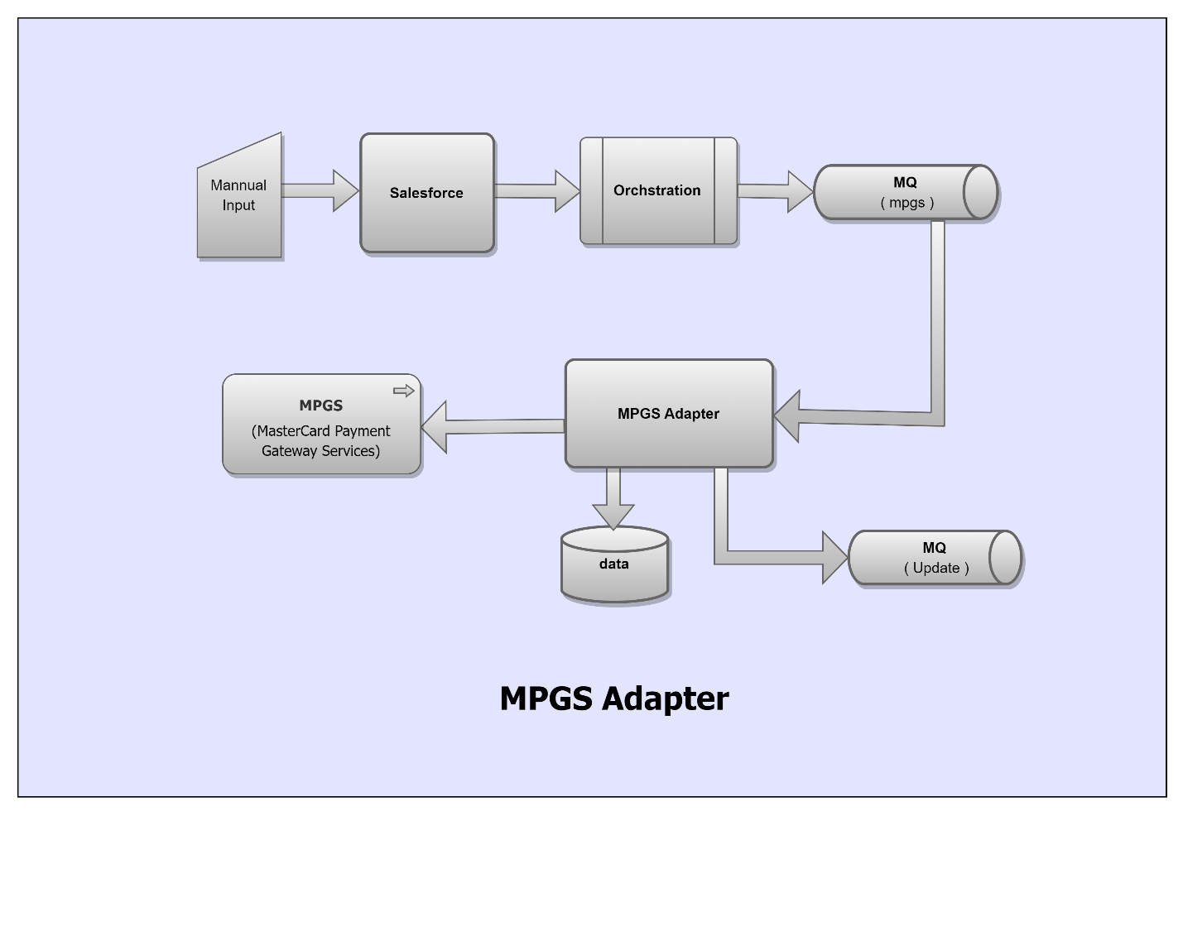

Sub Component
- Salesforce - User will provide inputs merchant id, merchant name, request type to call merchant onboarding services.

- Orchestration - will redirect payload to RabbitMQ.

- RabbitMQ - will serve payload to MPGS adapter which is continuously listen to RabbitMQ

- Adapter - will consume payload. Adapter will validate payload whether payload data is in proper format or not. Payload which is valid, will persist in database and call to MPGS API. API Response of merchant-create/update will pass to RabbitMQ and task history will be store in database

- MPGS : MPGS API is used to create or update merchant details. The related information should be passed via salesforce payload to MPGS Adapter. This adapter invokes the MPGS API to onboard/Update Merchant. The API response is sent back the status after the creation/update the merchant.

Class Diagram

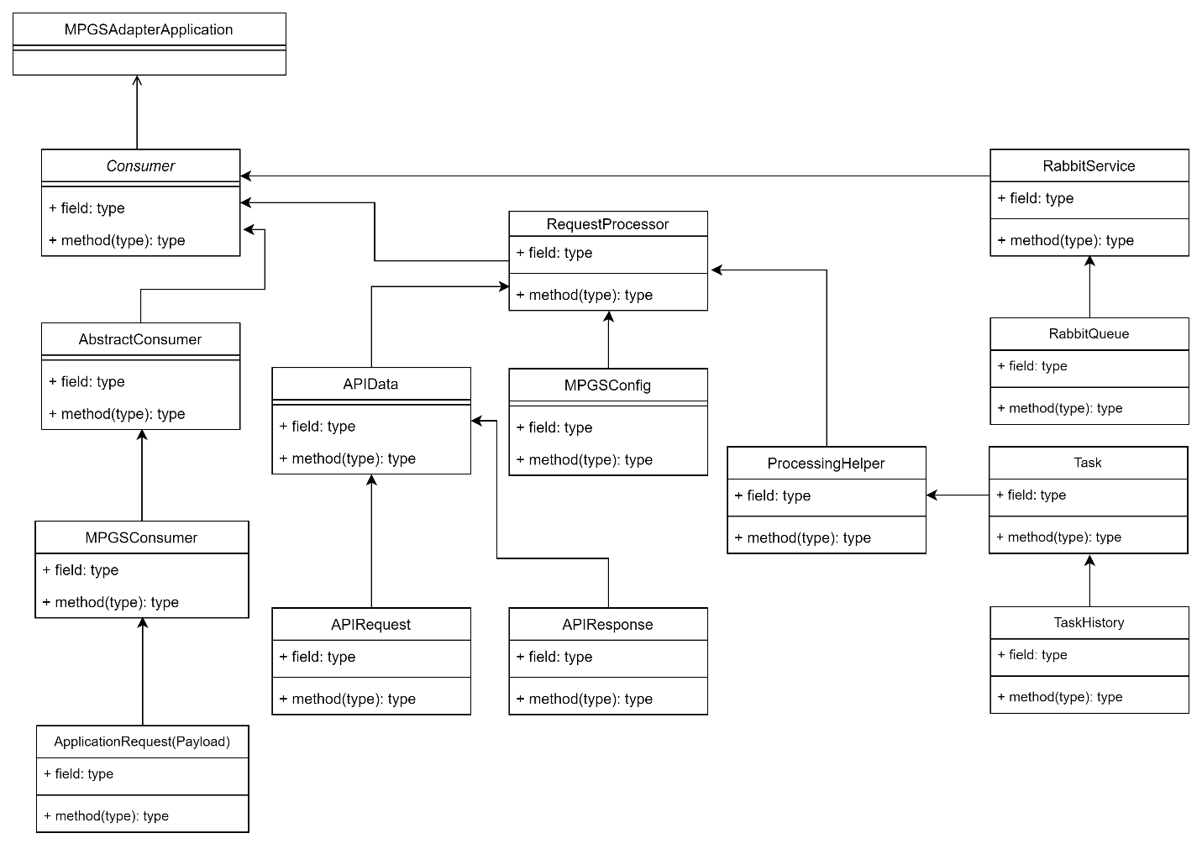

Use Cases

API Specification – CreateOrUpdate Merchant
URL https://test-network.mtf.gateway.mastercard.com/api/rest/version/69/mso/{msoId}/merchant/{merchantId}
HTTP Method: PUT
Content Type: application/json
Accept: application/json

Authentication
This operation requires authentication via one of the following methods:
- Certificate authentication.
- Basic HTTP authentication as described at w3.org. Provide 'MSO.<gateway MSO ID>' in the userid portion and API password in the password portion.
Basic HTTP authentication
HTTP-based communication, basic method is the means of authenticating end-users before granting access to resources or communication. For the same, intended users are instructed to deliver primary credentials like user name and login password.
In this method, the base-64 encoded data is transmitted through an Authorization Header.
As it doesn’t demand cookies, login pages, and other identifiers to come into action, it’s considered as the most austere user-authentication technique helping in achieving full access control.

Request Sample POS :
{
"apiOperation": "CREATE_OR_UPDATE_MERCHANT",
"merchant": {
"acquirerLink": {
"NETWORK_LLC_S2I01": {
"accountUpdaterEnabled": false,
"acquirerId": "NETWORK_LLC_S2I",
"allowableTransactionFrequency": [
"SINGLE_TRANSACTION"
],
"bankMerchantId": "2022121512",
"allowableTransactionSource": [
"CARD_PRESENT"
],
"authentication": null,
"cardType": [
"MASTERCARD",
"VISA"
],
"currency": [
"AED"
],
"defaultTransactionFrequency": "SINGLE_TRANSACTION",
"defaultTransactionSource": "CARD_PRESENT",
"paymentType": "CREDIT",
"status": "TEST_AND_PRODUCTION",
"terminalId": [
"A5718675",
"B5718675",
"C5718675",
"D5718675",
"E5718675"
]
}
},
"address": {
"street1": "AL BARSHA 1",
"street2": null,
"city": "Johannesburg",
"stateProvince": "JNB",
"postcode": "0000000784",
"countryCode": "ZAF"
},
"cardMaskingFormat": "DISPLAY_6_4",
"categoryCode": "5814",
"contactName": " MHM",
"defaultOrderCertainty": "FINAL",
"email": "Moorthy.*****************",
"goodsDescription": "prop description",
"webSite": null,
"locale": "en_US",
"timeZone": "Asia/Dubai",
"name": "Test restuarents LLC",
"partnerManagedRiskAssessment": null,
"phone": "508008434",
"privilege": [
"AUTHORIZATIONS",
"AUTO_AUTH_REVERSAL_ON_EXPIRY",
"CAPTURES",
"CHANGE_MERCHANT_TRANSACTION_SOURCE",
"CHANGE_TRANSACTION_FREQUENCY",
"ORDER_DOWNLOAD",
"PURCHASES",
"REFUNDS",
"VOIDS",
"ENFORCE_UNIQUE_ORDER_REFERENCE",
"ENFORCE_UNIQUE_MERCHANT_TRANSACTION_REFERENCE"
],
"service": [
"ENABLE_WEB_SERVICES_API"
],
"state": "ENABLED",
"systemCapturedCardMaskingFormat": "DISPLAY_6_4",
"transactionFiltering": null,
"certificateSetId": "***",
"administrativePassword": "**********",
"tradingName": "Test restuarents LLC"
}
}

Request Sample EOM :
{
"apiOperation": "CREATE_OR_UPDATE_MERCHANT",
"merchant": {
"acquirerLink": {
"NETWORK2_S2I01": {
"accountUpdaterEnabled": false,
"acquirerId": " NETWORK2_S2I",
"allowableTransactionFrequency": [
" SINGLE_TRANSACTION"
],
"allowableTransactionSource": [
" INTERNET"
],
"authentication": {
"masterCardSecureCode": {
"3DS1": {
"merchantId": "451710650999"
}
},
"verifiedByVisa": {
"3DS1": {
"cardAcceptorId": "451710650999",
"cardAcceptorTerminalId": "57186750"
}
}
},
"bankMerchantId": "451710650999",
"cardType": [
"MASTERCARD",
"VISA"
],
"currency": [
"AED"
],
"defaultTransactionFrequency": "SINGLE_TRANSACTION",
"defaultTransactionSource": "INTERNET",
"enforceCscOnTransactionSource": [
"INTERNET"
],
"paymentType": "CREDIT",
"status": "TEST_AND_PRODUCTION",
"terminalId": [
"A5718675",
"B5718675",
"C5718675",
"D5718675",
"E5718675"
]
}
},
"address": {
"street1": "AL BARSHA 1",
"street2": null,
"city": "Johannesburg",
"stateProvince": "JNB",
"postcode": "0000000784",
"countryCode": "ZAF"
},
"cardMaskingFormat": "DISPLAY_6_4",
"categoryCode": "5814",
"contactName": " MHM",
"defaultOrderCertainty": "FINAL",
"email": "Moorthy.*****************",
"goodsDescription": "goods description",
"webSite": "https://wwww.vzImNQBdUd.com",
"locale": "en_US",
"timeZone": "Asia/Dubai",
"name": "Test restuarents LLC",
"partnerManagedRiskAssessment": {
"transactionRiskAssessment": {
"configuration": "STANDARD"
}
},
"phone": "508008434",
"privilege": [
"AUTHORIZATIONS",
"AUTO_AUTH_REVERSAL_ON_EXPIRY",
"CAPTURES",
"CHANGE_MERCHANT_TRANSACTION_SOURCE",
"CHANGE_TRANSACTION_FREQUENCY",
"ORDER_DOWNLOAD",
"PURCHASES",
"REFUNDS",
"SECURECODE_2",
"TXN_DOWNLOAD",
"VERIFIED_BY_VISA_2",
"VOIDS",
"ENFORCE_UNIQUE_ORDER_REFERENCE",
"ENFORCE_UNIQUE_MERCHANT_TRANSACTION_REFERENCE"
],
"service": [
"ENABLE_HOSTED_PAYMENT_FORM",
"ENABLE_CHECKOUT_VIA_MERCHANT_WEBSITE",
"ENABLE_NOTIFICATIONS",
"ENABLE_REPORTING_API",
"ENABLE_WEB_SERVICES_API",
"ENABLE_MSO_CONFIGURED_TRANSACTION_FILTERING"
],
"state": "ENABLED",
"systemCapturedCardMaskingFormat": "DISPLAY_6_4",
"transactionFiltering": {
"dynamic3DSecure": false,
"ipCountry": {
"rejectAnonymousProxy": false,
"rejectUnknownCountry": false
}
},
"certificateSetId": "****************",
"administrativePassword": "**********",
"risk": {
"privilege": [
"SYSTEM_REFUND"
]
}
}
}

Response
Below are the response code and the reason description for the response in order the API calls performed.
Success
Information on Success conditions that may occur while processing an operation using the API.
Response
{
"correlationId": "as12213daa&23"
"result": "SUCCESS"
}

correlationId String
A transient identifier for the request, that can be used to match the response to the request.
The value provided is not validated, does not persist in the gateway, and is returned as provided in the response to the request.
Existence CONDITIONAL
Validation Rules
Data can consist of any characters.
XSD type string
minimum length 1
maximum length 100

result Enumeration
A system-generated high level overall result of the operation.
Existence Always Provided
Validation Rules
JSON type String
Value must be a member of the following list. The values are case sensitive.
FAILURE The operation was declined or rejected by the gateway, acquirer or issuer.
PENDING The operation is currently in progress or pending processing.
SUCCESS The operation was successfully processed.
UNKNOWN The result of the operation is unknown.

ERROR
Information on possible error conditions that may occur while processing an operation using the API.
Response
{
"error": {
"cause": "INVALID_REQUEST",
"explanation": "Value 'xxxx' is invalid. Invalid value",
"field": "xxxx.xxxx",
"validationType": "INVALID"
},
"result": "ERROR"
}

error.cause Enumeration
Broadly categorizes the cause of the error.
For example, errors may occur due to invalid requests or internal system failures.
Validation Rules
JSON type String
Value must be a member of the following list. The values are case sensitive.
INVALID_REQUEST - The request was rejected because it did not conform to the API protocol.
REQUEST_REJECTED - The request was rejected due to security reasons such as firewall rules, expired certificate, etc.
SERVER_BUSY - The server did not have enough resources to process the request at the moment.
SERVER_FAILED - There was an internal system failure.
error.explanation String
Textual description of the error based on the cause.
This field is returned only if the cause is INVALID_REQUEST or SERVER_BUSY.
Validation Rules
Data can consist of any characters.
JSON type String
minimum length 1
maximum length 1000

error.field String
Indicates the name of the field that failed validation.
This field is returned only if the cause is INVALID_REQUEST and a field level validation error was encountered.
Validation Rules
Data can consist of any characters.
JSON type String
minimum length 1
maximum length 100

error.supportCode String
Indicates the code that helps the support team to quickly identify the exact cause of the error.
This field is returned only if the cause is SERVER_FAILED or REQUEST_REJECTED.
Validation Rules
Data can consist of any characters.
JSON type String
minimum length 1
maximum length 100

error.validationType Enumeration
Indicates the type of field validation error.
This field is returned only if the cause is INVALID_REQUEST and a field level validation error was encountered.
Validation Rules
JSON type String
Value must be a member of the following list. The values are case sensitive.
INVALID The request contained a field with a value that did not pass validation.
MISSING The request was missing a mandatory field.
UNSUPPORTED The request contained a field that is unsupported.

result Enumeration
A system-generated high level overall result of the operation.
Validation Rules
JSON type String
Value must be a member of the following list. The values are case sensitive.
ERROR The operation resulted in an error and hence cannot be processed.

CreateOrUpdate Merchant
Operation to CreateOrUpdate (create or update) a merchant and define the merchant's general details.
The Merchant Boarding API allows to automatically board merchants onto the Mastercard Payment Gateway. By integrating the Merchant Boarding API with business application, can create, update, and approve merchant accounts without having to manually configure a merchant in Merchant Manager. This is useful when merchant data readily available in business application (a Customer Relationship Management or Sales management tool) or provided directly by the merchant entering it in an online form. The Merchant Boarding API thereby allows to increase the rate of merchant boarding by reducing the time lag between data collection and account activation.
Create or Update Merchant: It allows to
- create or update a merchant account and set general details.
- add or update the configuration for an acquirer link that is used by the merchant for payment processing.
- add or update payment configuration details for an existing merchant.
You can initiate requests for updating merchant details in any order after you have successfully created the merchant using the Update Merchant or Create or Update Merchant request. You must send the Approve Merchant request to enable the changes to take effect.

Note the following before building your integration:
- All the requests for the Merchant Boarding API are idempotent, which means if you re-submit an identical request, the Merchant Boarding API will return the same response as the first request. This means that if you did not receive a response for a request, you can re-submit the same request without having to worry about the side effects.
- When updating any details for a merchant account, if you do not provide a field in the request, then the Merchant Boarding API overwrites the existing value for that field with NULL. For example, if you have created a merchant account with the trading identifier (merchant.tradingId), and you do not provide this field in a subsequent Update Merchant or Create or Update Merchant request, then the existing value for the trading identifier is erased.
- Some fields in the requests such as identifiers and passwords can contain sensitive data; hence please ensure that your business application handles them securely.
- The Merchant Boarding API and Merchant Manager may be used interchangeably to create/update merchant account details at any time throughout the merchant boarding process. For functionality that is currently not supported via the Merchant Boarding API, but via Merchant Manager only, see the last section.
To enable a feature via the Merchant Boarding API, you must provide all the mandatory fields specific to that feature. However, note that the feature will be enabled only if your MSO has the requisite privileges.

Benefits of Create OR Update Merchant operation
- The CreateOrUpdate API operation enables the MSO to add or update a merchant account in a single API call.
- The API is aligned with the Retrieve Merchant API response, enabling an MSO to retrieve a merchant configuration and submit the entire merchant configuration with any changes.
- The API operation allows you to add or update multiple acquirer links, removing the need to submit multiple API calls and supports the removal of acquirer links.

Update a merchant account information
When updating or creating a merchant account, you must submit all merchant fields that you want to retain. If you omit a field, such as merchant address or acquirer link, the field is set to NULL and the data is removed. It is recommended to use the following steps for integration.
For any change such as update field, delete field, and add field to the merchant configuration:
- Call the Retrieve Merchant operation. It will return actual values for the fields that are populated. Fields that are left blank will not be returned.
- Make the necessary changes to all fields that it returns.
  - Changes: update the returned value with a new value.
  - Deletions: remove the field from the next step.
  - Additions: provide the name of the new field and its value. For more information about all available fields, refer to CreateOrUpdate operation.
All mandatory fields must be completed for the Create or Update operation to succeed.
- Submit all fields, including updated fields, through the Create or Update operation.

Limitations of the Merchant Boarding API
In the current release of the Merchant Boarding API, the following limitations apply to creating/updating merchant accounts. You can use Merchant Manager to work around these limitations.
- You cannot delete a merchant.
You can delete merchant accounts (irrespective of whether they are approved or not) in Merchant Manager only if you have the privilege 'Delete Merchant Profile' and if there are no transactions against that merchant account.
- If you create a new merchant account with the same identifier as an existing account, the new account details override the existing account details.
- You cannot update an existing token repository.
- You cannot update an existing intercepts tenant profile. In addition, you cannot change the intercepts tenant profile assigned to a merchant if the merchant currently has a profile assigned and is the lead merchant for that profile.

Deployment Diagram
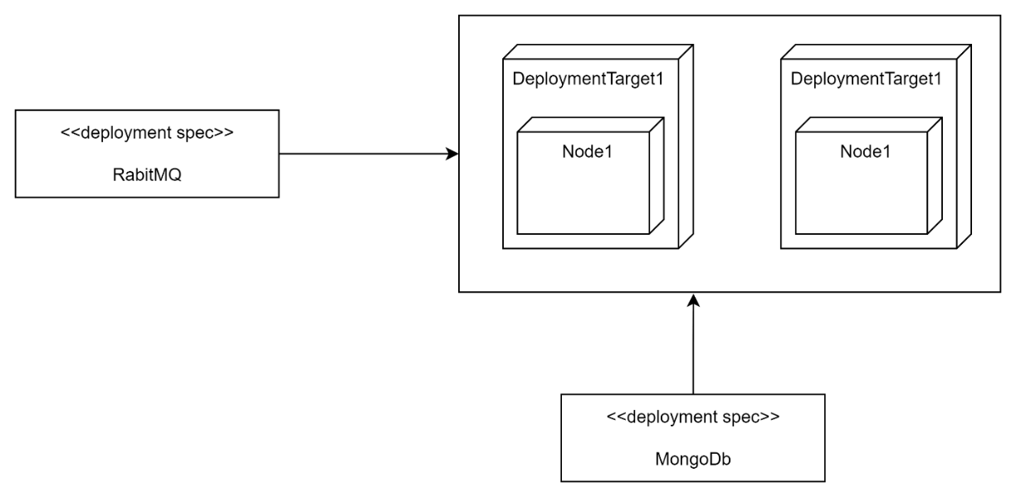

Other Interfaces
Identify any external interfaces used in the execution of this module, include technology and other pertinent data.

Interface X
Message details describe in attached file.

Outstanding Issues
- Outstanding Issue - Get/Query for Merchant details – This is not included, since requirement and payload structure are not finalized yet.

Non Functional Requirement
Non-Functional Requirement | Definition
Maintainability | Ease to change and evolve with minimal effort
Security | Encryption, password controls, storing and handling of personal and sensitive data
Testability | Ease to confirm conformance by observing a reproducible behavior
Portability | Ease to reuse for multiple platforms
Extensibility | Ease to takes into consideration future growth
Whitelisting Domain/Ips | NI’s domain and IP should be whitelist into MPGS before deployment in production

References
API Operation CreateOrUpdate Merchant (mastercard.com)

Glossary
Acronym | Full form
NI | Network International
MQ | Message Queue
IP | Internet Protocol
API | Application Program Interface
MPGS | Mastercard Payment Gateway Services

